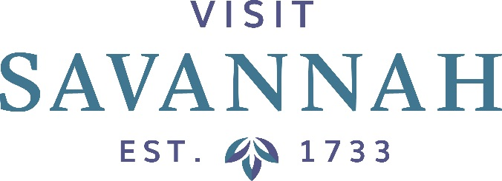
EXECUTIVE COMMITTEE MEETING
Large Conference Room or Zoom
101 East Bay Street

Friday, October 2, 2020
12:00 Noon

This Meeting is Open to the Public

- Call to Order and Welcome: Visit Savannah Chairman Pritpal Singh

- Pritpal Singh / Jonathan Claughton / Joseph Marinelli
- Minutes
- Financials
- Hotel/Motel Tax Collections Report
- Smith Travel Research Report
- Convention and Group Tour Sales Production Report

- President’s Report: Joseph Marinelli
- Current Activities/Events Update
- Other

- Chairman’s Report

- New Business

- Announcements

- Adjournment

