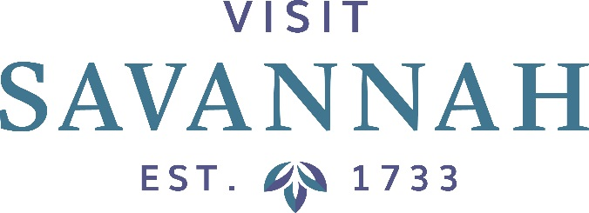
Board of Directors Meeting
Will be Held at
Perry Lane Hotel
The Ballroom

Friday, June 15, 2018
At 8:30 AM

This Meeting is Open to the Public

- Welcome and Meeting Agenda: Visit Savannah Chairman Vaughnette Goode-Walker

- Vaughnette Goode-Walker/Corey Jones/Joseph Marinelli
- Minutes
- Financials
- Hotel/Motel Tax Collections Report
- Smith Travel Research Report

- President’s Report: Joseph Marinelli
- Current Activities/Events Update
- Other

- Designee Reports

- Savannah Chamber of Commerce Report: Bill Hubbard

- Old Business

- New Business

- Adjournment

Announcements

