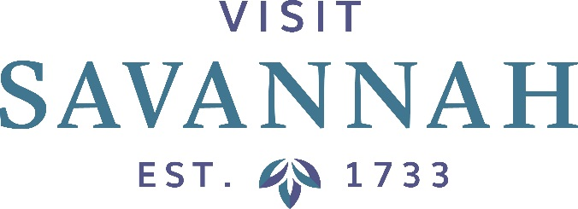
Board of Directors Meeting
Large Conference Room
101 East Bay Street

Friday, October 11, 2019, 8:30 AM

This Meeting is Open to the Public

- Call to Order and Welcome: Visit Savannah Chairman Dave Legasse

- Dave Legasse/Corey Jones/Joseph Marinelli
- Minutes
- Financials
- Hotel/Motel Tax Collections Report
- Smith Travel Research Report
- Convention Transportation Fund Update

- President’s Report: Joseph Marinelli
- Current Activities/Events Update
- Other

- Department Reports

- Chairman’s Report

- Savannah Chamber Update: Bill Hubbard

- Designee Reports

- Old Business

- New Business

- Adjournment

Announcements

