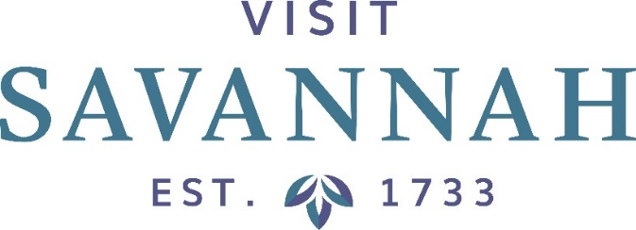
Executive Committee Meeting

Large Conference Room
101 East Bay Street

Thursday, June 7, 2018
8:30 AM

This Meeting is Open to the Public

- Agenda Outline

- Meeting Minutes Approval

- Financial Reports:

- Statement of Financial Position & Statement of Revenues & Expenditures Approval
- Hotel/Motel Room Tax Collections Report
- Smith Travel Research Report

- President’s Report: Joseph Marinelli

- Current Events Update
- Marketing and Advertising Update
- Other

- Miscellaneous/Other

Announcements

